International Workshop of Energy Conversion 2023

IWEC2023 Program (tentative)
Kambaikan Building, Muromachi Campus,
Doshisha University, Kyoto

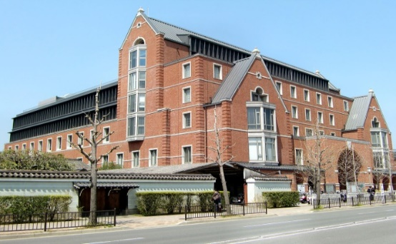
＜March 15, Wednesday＞
Reception and Welcome party
13:00-18:30 Reception at reception desk
19:00-20:30 Welcome party

＜March 16, Thursday＞
Opening ceremony
09:00-09:10 Opening
09:10-09:20 Opening speech
Prof. Minoru Inaba
Director of Energy Conversion Research Center, Doshisha University

09:20-09:30 Short break (Preparation of talk)

Session 1: Energy Storage and Transportation of Energies 1
09:30-09:50 Talk 01
P. Yu
09:50-10:10 Heat transfer characteristics in Rayleigh-Bénard convection of temperature sensitive magnetic fluid with fluid-particle interaction
M.-F. Chen
10:10-10:30 Convection in bidisperse porous media
S. Saravanan

10:30-10:50 Coffee break

Session 2: High Efficiency Energy Conversion Systems
10:50-11:10 Development of La0.6Sr0.4CoO3-δ anode for oxygen generation by molten salt electrolysis
S. Tanaka¹, Y. Suzuki¹, T. Fukumoto², T. Goto²
¹Office for Research Initiatives and Development, Doshisha University, Kyoto, Japan
²Faculty of Science and Engineering, Doshisha University, Kyoto, Japan
11:10-11:30 Solar energy to electric energy
P. Kandaswamy
11:30-11:50 Talk 06
C. Pumaneratkul

Session 3: Keynote lecture
11:50-12:20 Numerical simulations of ferrofluid droplets and surface instabilities in ferrofluid layers
X.-D. Niu^{1,2}, J.-X. Zhou^{1,2}, H.-W. Xiao^{1,2}, A. Khan^{1,2}, M.-F. Chen³, D.-C. Li⁴, H. Yamaguchi⁵
¹Key Laboratory of Intelligent Manufacturing Technology, Shantou University, Guangdong, China
²College of Engineering, Shantou University, Guangdong, China
³College of Physics and Electromechanics Engineering, Longyan University, Longyan, China
⁴Department of Mechanical Engineering, Tsinghua University, Beijing, China
⁵Energy Conversion Research Center, Doshisha University, Kyoto, Japan
12:20-13:30 Lunch

Session 4: Energy Conversion and Related Research Topics 1
13:30-13:50 Medium scale distribution chains for hydrogen

P. Nekså^{1,2}, M. Z. Saeed², S. Trædal¹, I. Snustad¹, I. Koshelkov² ,L. D. Jacobsen ²
¹SINTEF Energy Research, Trondheim, Norway
²NTNU, Department of Energy and process engineering, Trondheim, Norway
13:50-14:10 Recycling of fisheries waste
H. Kobatake, S. Tanaka, Y. Suzuki, T. Goto
Doshisha University, Kyotanabe, Japan
14:10-14:30 Reduction in energy consumption in water purification technology with water
T. Kuwahara
Department of Mechanical Engineering, Nippon Institute of Techinology, Saitama, Japan
14:30-14:50 Neural Networks and support vector regression in building energy prediction
F. Magoules

14:50-15:10 Coffee break

Session 5: Flow and Heat transfer Session
15:10-15:30 Talk 12
H. Yamasaki
15:30-15:50 Heat transpot characteristics of a closed two phase thermosyphon by water with air mixed (effect of the internal structure)
T. Kitamura, T. Kubota, S. Shuchi
Department of Mechanical Engineering, Akita Prefectural University, Akita, Japan
15:50-16:10 Interfacial behaviors of magnetic multiphase flows in microscale
X. Li

16:10-16:30 Coffee break

Session 6: Energy Storage and Transportation of Renewable Energies 2
16:30-16:50 Prediction of nozzle jet using physics-informed neural networks
Y.-Z. Wang
16:50-17:10 Energy storage method based on carbon dioxide
Y. Nie
17:10-17:30 Innovative approach to recover thermal storage tanks losses during standstill demands period. A numerical study.
H. Elarga

17:30-17:40 Announcement

18:00-20:30 Banquet

＜March 17, Friday＞
Session 7: Energy Storage and Transportation of CO₂
09:30-09:50 CERN CO₂ primary cooling – Project roadmap and first operational units
P. Barroca¹, A. Hafner¹, B. Verlaat², P. Hanf²
¹Norwegian University of Science and Technology
²European Organization for Nuclear Research (CERN), Geneva, Switzerland
(NTNU), Trondheim, Norway
09:50-10:10 Performance improvement strategies for CO₂ based experimental Rankine cycle for better sustainability
O. Kizilkan
10:10-10:30 MW-scale supercritical CO₂ power generation system and efficiency
L. Chen

10:30-10:50 Coffee break

Session 8: Energy Conversion and Related Research Topics 2
10:50-11:10 One-step reduction process of silica to silicon by molten salt electrolysis
Y. Suzuki¹, S. Tanaka¹, T. Goto²
¹Organization for Research Initiatives and Development, Doshisha University, Kyoto, Japan
²Department of Science of Environment and Mathematical Modeling Graduate School of Science and Engineering, Kyoto, Japan
11:10-11:30 PM removal characteristics in magnetic fluid filter with dielectric barrier discharge
Y. Asaka, T. Kuwahara
Department of Mechanical Engineering, Nippon Institute of Technology, Saitama, Japan
11:30-11:50 Talk 23
Y. Iwamoto
11:50-13:00 Lunch

Session 9: Keynote lecture
13:00-13:30 Keynote lecture 24
H. Yamaguchi

Closing ceremony
13:30-13:40 Closing speech
Prof. Hiroshi Yamaguchi
Organizer of IWEC 2023, Doshisha University
13:40-13:50 Closing

